Curriculum Vitae

Personal Information
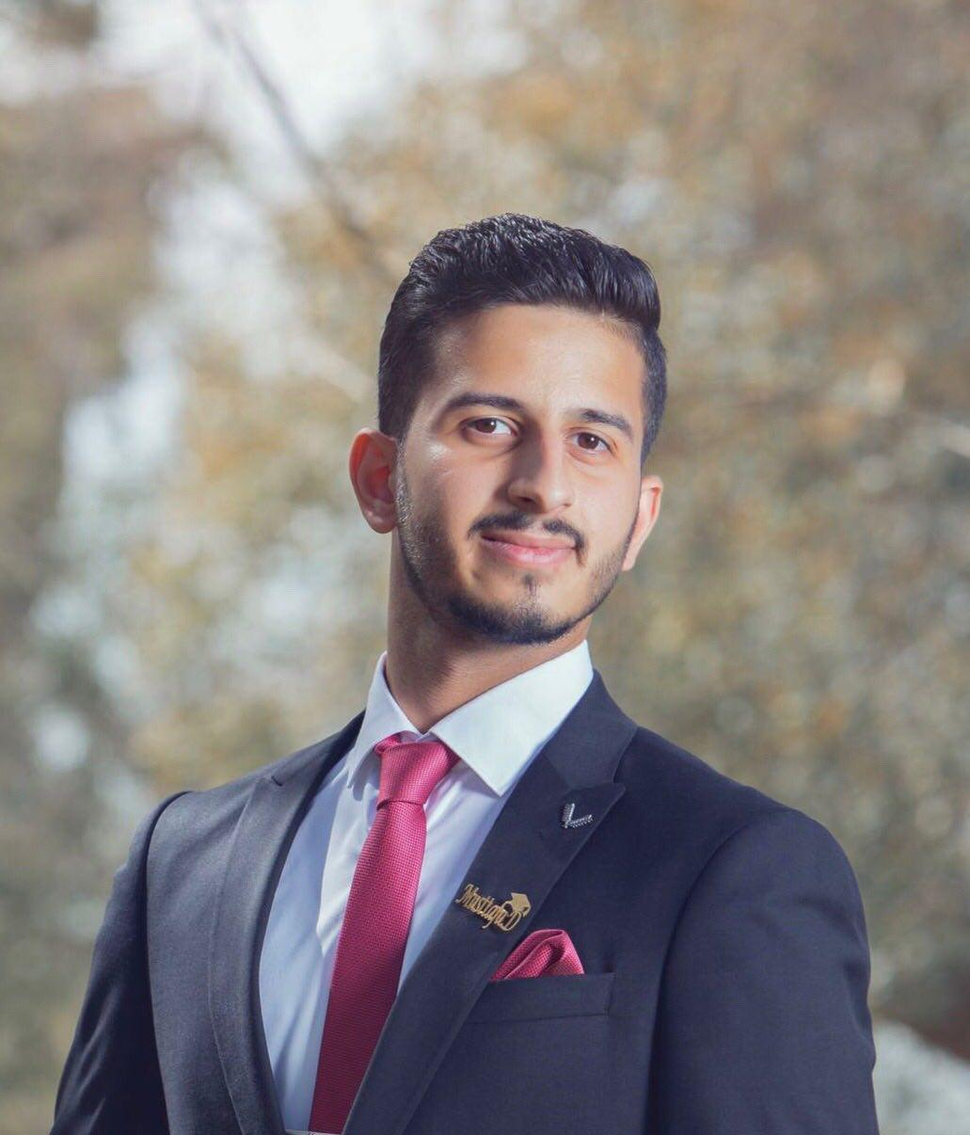
Name : Mustafa Dhurgam Shamsaldeen
Nationality : Iraqi
Date of Birth : 30/3/1996
Place of Birth : Baghdad
Sex : Male
Marital Status : Single
Religion : Islamic

Contact Details

Address : Baghdad –Alharthyai- alkindi street
Mob : 07902839667
Email : mustafa07902839667@yahoo.com

Education

Graduate : Baghdad College of Economic Sciences
Graduation Year: 2018
Department : Accounting

Languages & Typing Skills

English : normal
Arabic : good

Computer Skills

- Multi Computer user
- Microsoft office (word /excel)
- Internet

Training & other courses

-I trained in the distribution of Baghdad for oil products for one month.

-I worked for Saudi Fabco Plastic Pipes Company
And Turkish company Egeplast Pipes during the Baghdad International Fair.

